Supplementary file
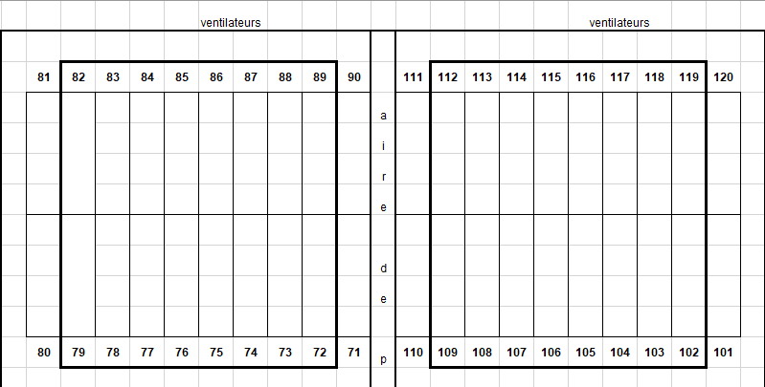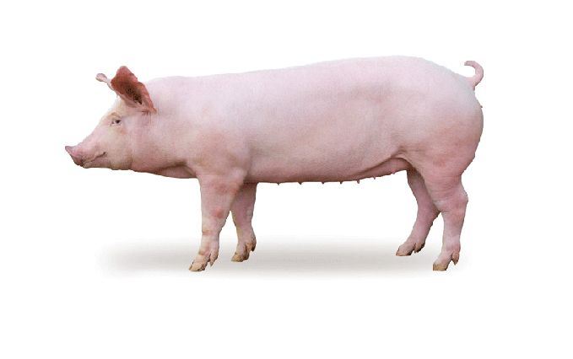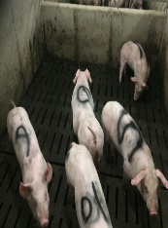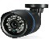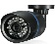
Pen area
Enclos
Room 1
Room 2

Figure S1
On farm experimental setting. A total of 352 pigs were distributed into two rooms in which 32 (2 x 16) flat deck pens of 2.06 m x 3.35 m were used. There were 11 pigs per pen (six females and five males). To facilitate the recognition of individuals in a pen, a colored number from 0 to 10 was painted on the animal’s back. This labeling was supplementary to the ear-tag system already in place in the herd. Their behavior was monitored using 16 surveillance cameras.

Figure S2
Non-metric multidimensional scaling (NMDS) Yue and Clayton index plot illustrating the comparison of intestinal microbiota of the ATB treated positive control group with the negative control pigs. t0: started right after the selection of the groups. t1: started four weeks later. Green: negative control pigs; purple: ATB treated positive control group.

Table S1. Genera and OTUs associated with the biter pig group compared to the negative control pig group at t0
GENERA | Taxonomy | Group | LDA | pValue
Coprococcus | B.F.C.Clostridiales.Lachnospiraceae | biter | 3.30 | 0.0163
Clostridium_IV | B.F.C.Clostridiales.Ruminococcaceae | biter | 2.69 | 0.0312
Lactobacillus | B.F.Bli.Lactles.Lactctobacillaeae | N. control | 4.47 | 0.0031
Butyricicoccus | B.F.C.Cles.Bacteroidales | N. control | 3.54 | 0.0363
Pseudobutyrivibrio | B.F.C.Cles..Lachnospiraceae | N. control | 2.54 | 0.0163
OTUs | Taxonomy | Group | LDA | pValue
Otu00020 | B.Btes.Bacteroidetes_ucld | biter | 4.03 | 0.0097
Otu00069 | B.Firmicute_ucld | biter | 3.41 | 0.0007
Otu00045 | B.F.C.Cles.Lachnoe.Coprococcus | biter | 3.25 | 0.0163
Otu00096 | B.Btes.Bdia.Bles.Prceae.Prevotella | biter | 3.01 | 0.0476
Otu01288 | B.F.C.Cles.Ruminoc.Faecalibacterium | biter | 2.86 | 0.0404
Otu00128 | B.F.C.Cles.Lachno.Blautia | biter | 2.79 | 0.0363
Otu00027 | B.Btes.Btes_ucld | biter | 2.77 | 0.0116
Otu00139 | B.Btes.Bdia.Bles.Prceae.Alloprevotella | biter | 2.72 | 0.0363
Otu00107 | B.Btes.Btes_ucld | biter | 2.70 | 0.0263
Otu01045 | Clostridiales_ucld | biter | 2.66 | 0.0036
Otu01146 | Clostridia_ucld | biter | 2.65 | 0.0404
Otu01361 | B.Btes.Bdia.Bles.Prceae.Prevotella | biter | 2.63 | 0.0414
Otu00975 | Ruminococcaceae_ucld | biter | 2.61 | 0.0113
Otu00797 | Clostridiales_ucld. | biter | 2.60 | 0.0404
Otu01377 | B.Firmicutes_ucld | biter | 2.60 | 0.0404
Otu01071 | Clostridiales_ucld | biter | 2.58 | 0.0299
Otu01557 | Lachno_ucld | biter | 2.54 | 0.0404
Otu00169 | Clostridiales_ucld | biter | 2.54 | 0.0011
Otu00152 | B.Btes.Bdia.Bles.Prceae.Prevotella | biter | 2.54 | 0.0225
Otu00797 | Clostidiales_ucld | biter | 2.52 | 0.0404
Otu01506 | Bacteroidale_ucld | biter | 2.50 | 0.0404
Otu01628 | B.Btes.Bdia.Bles.Prceae.Prevotella | biter | 2.49 | 0.0404
Otu00002 | B.F.Bacilli.Lactles.Lactceae.Lactobacillus | N. control | 4.51 | 0.0016
Otu00016 | B.F.C.Cles.Lachno.Cellulosilyticum | N. control | 3.94 | 0.0056
Otu00037 | B.Btes.Bdia.Bles.Prceae.Prevotella | N. control | 3.42 | 0.0163
Otu00142 | Actinobacterium_ucld | N. control | 3.17 | 0.0193
Otu00164 | Ruminococcaceae_ucld | N. control | 3.02 | 0.0163
Otu00132 | B.F.C.Cles.Peptococcaceae_1.Peptococcus | N. control | 2.86 | 0.0488
Otu01257 | B.F.C.Cles.Ruminoc.Ruminococcaceae_ucld | N. control | 2.77 | 0.0254
Otu00245 | B.Btes.Bdia.Bles.Prceae.Prevotella | N. control | 2.76 | 0.0422
Otu01360 | B.F.C.Clostridiales_ucld | N. control | 2.76 | 0.0105
Otu01975 | B.F.C.Cles.Lachno.Dorea | N. control | 2.76 | 0.0254
Otu01968 | Porphyromonadaceae_ucld | N. control | 2.73 | 0.0254
Otu00267 | B.Btes.Bdia.Bles.Prceae.Paraprevotella | N. control | 2.71 | 0.0362
Otu02401 | Ruminococcaceae_ucld | N. control | 2.70 | 0.0254
Otu01725 | B.Btes.Bdia.Bles.Prceae.Prevotella | N. control | 2.62 | 0.0141
Otu00258 | B.Oxalobacteraceae_ucld | N. control | 2.61 | 0.0080
Otu00241 | B.Prote.Gprot.Aerles.Suceae.Succinivibrio | N. control | 2.61 | 0.0312
Otu00181 | B.Spiro.Spirotia.Spiroles.Spiroceae.Treponema | N. control | 2.58 | 0.0116
Otu00175 | B.F.C.Cles.Lachno.Pseudobutyrivibrio | N. control | 2.54 | 0.0163
Otu00159 | B.F.C.Cles.Ruminoc.Oscillibacter | N. control | 2.54 | 0.0488

Table S2. Genera and OTUs associated with the biter pig group compared to the negative control pig group at t1
GENERA | Taxonomy | Group | LDA | pValue
Roseburia | B.F.C.Cles.Lachnospiraceae | N. control | 3.23 | 0.0422
Anaeroplasma | Anaeroplasmataceae.Anaeroplasma | N. control | 2.91 | 0.0422
OTUs | Taxonomy | Group | LDA | pValue
Otu00051 | B.F.C.Cles.Lachnospiraceae_ucld | N. control | 3.46 | 0.0193
Otu00075 | B.Btes.Bdia.Bacteroidales_ucld | N. control | 3.39 | 0.0004
Otu00035 | B.F.C.Clostridiales_ucld | N. control | 3.23 | 0.0422
Otu00114 | B.F.C.Cles.Lachnospiraceae_ucld | N. control | 2.89 | 0.0312
Otu00093 | B.Bacteroidetes_ucld | N. control | 2.79 | 0.0116
Otu00149 | B.F.C.Clostridiales_ucld | N. control | 2.69 | 0.0266
Otu00160 | B.F.C.Cles.Ruminococcaceae_ucld | N. control | 2.64 | 0.0193
Otu00267 | B.Btes.Bdia.Bles.Prceae.Paraprevotella | N. control | 2.64 | 0.0422
Otu00210 | B.Btes.Bdia.Bles.Porphyromonadaceae_ucld | N. control | 2.50 | 0.0267

Table S3. Genera and OTUs associated with the bitten pig group compared to the negative control pig group at t0
GENERA | Taxonomy | Group | LDA | pValue
Sphaerochaeta | B.Spt.Sptia.Sptales.Sptceae | bitten | 3.21 | 0.0056
Blautia | B.F.C.Cles.Lachnospiraceae | bitten | 2.96 | 0.0312
Lactobacillus | B.F.Bacilli.Lactobacillales.Lactobacillaceae | N. control | 4.57 | 0.0068
Intestinimonas | B.F.C.Cles.Ruminoc | N. control | 3.38 | 0.0363
OTUs | Taxonomy | Group | LDA | pValue
Otu00010 | B.F.Nega.Sel8moles.Ac.Phascolarctobacterium | bitten | 3.61 | 0.0487
Otu00027 | B.Btes.Btes_ucld.Btes_ucld.Btes_ucld.Btes_ucld | bitten | 3.26 | 0.0138
Otu00104 | B.Btes.Bdia.Bles.Bles_ucld.Bles_ucld | bitten | 3.18 | 0.0068
Otu01288 | B.F.C.Cles.Ruminoc.Faecalibacterium | bitten | 3.17 | 0.0405
Otu00174 | B.Spt.Sptia.Sptales.Sptceae.Sphaerochaeta | bitten | 3.16 | 0.0423
Otu01451 | B.Btes.Bdia.Bles.Porphy.Parabacteroides | bitten | 2.90 | 0.0191
Otu00069 | B.F.F_ucld.F_ucld.F_ucld.F_ucld | bitten | 2.87 | 0.0068
Otu01334 | B.ActinoB.ActinoB.CorioBles.CorioBceae.ucld | bitten | 2.85 | 0.0405
Otu00128 | B.F.C.Cles.Lachnospiraceae.Blautia | bitten | 2.71 | 0.0267
Otu00950 | B.Btes.Bdia.Bles.prevceaee.Alloprevotella | bitten | 2.70 | 0.0405
Otu00152 | B.Btes.Bdia.Bles.prevceaee.Prevotella | bitten | 2.69 | 0.0132
Otu00169 | B.F.C.Cles.Cles_ucld.Cles_ucld | bitten | 2.69 | 0.0228
Otu00950 | B.Btes.Bdia.Bles.prevceaee.Alloprevotella | bitten | 2.67 | 0.0405
Otu01231 | B.F.C.Cles.Ruminoc.Ruminoc_ucld | bitten | 2.62 | 0.0405
Otu01557 | B.F.C.Cles.Lachnospiraceae.ucld | bitten | 2.55 | 0.0405
Otu00182 | B.F.C.Cles.Cles_ucld.Cles_ucld | bitten | 2.52 | 0.0228
Otu00266 | B.F.C.Cles.Lachnospiraceae.Blautia | bitten | 2.52 | 0.0228
Otu00002 | B.F.Bacilli.Lactles.Lactceae.Lactobacillus | N. control | 4.58 | 0.0031
Otu00016 | B.Btes.Bdia.Bles.Bles_ucld.Bles_ucld | N. control | 4.03 | 0.0011
Otu00054 | B.Btes.Bdia.Bles.prevceaee.Prevotella | N. control | 3.59 | 0.0423
Otu00090 | B.F.C.Cles.Ruminoc.Intestinimonas | N. control | 3.38 | 0.0192
Otu01257 | B.F.C.Cles.Ruminoc.Ruminoc_ucld | N. control | 2.62 | 0.0254
Otu00181 | B.Spt.Sptia.Sptales.Sptceae.Treponema | N. control | 2.59 | 0.0116
Otu01725 | B.Btes.Bdia.Bles.prevceaee.Prevotella | N. control | 2.59 | 0.0359
Otu00258 | B.ProteoB.BetaproteoB.BurKles.Oxalo. ucld | N. control | 2.55 | 0.0228
Otu01975 | B.F.C.Cles.Lachnospiraceae.Dorea | N. control | 2.51 | 0.0254

Table S4. Genus and OTUs associated with the bitten pig group compared to the negative control pig group at t1
GENUS | Taxonomy | Group | LDA | pValue
Alistipes | B.Btes.Bdia.Bles.Rikenellaceae | bitten | 2.91 | 0.036
OTUs | Taxonomy | Group | LDA | pValue
Otu00021 | B.Btes.Bdia.Bles.Prevotellaceae.Prevotella | bitten | 3.52 | 0.019
Otu00174 | B.Sptes.Sptia.Sples.Spceae.Sphaerochaeta | bitten | 3.01 | 0.042
Otu00029 | B.Btes.Bdia.Bles.Prevotellaceae.Prevotella | bitten | 2.95 | 0.042
Otu00157 | B.F.C.Cles.Cles_ucld.Cles_ucld | bitten | 2.78 | 0.019
Otu00200 | B.Bacteroidetes_ucld | bitten | 2.53 | 0.036
Otu00001 | B.Btes.Bdia.Bles.Prevotellaceae.Prevotella | N. control | 3.90 | 0.022
Otu00054 | B.Btes.Bdia.Bles.Prevotellaceae.Prevotella | N. control | 3.37 | 0.011
Otu00121 | B.Btes.Bdia.Bles.Prevotellaceae.Prevotellaceae_ucld | N. control | 2.82 | 0.036
Otu00231 | B.Btes.Bdia.Bles.Porphyceae.Porphy_ucld | N. control | 2.55 | 0.013
Otu00189 | B.F.C.Cles.Ruminoc.Ruminococcaceae_ucld | N. control | 2.51 | 0.036

Abbreviations:
B: Bacteria, Btes: Bacteroidetes, Bdia Bacteroidia: , Bles: Bacteroidales, F: Firmicute, C: Clostridia, Cles: Clostridiales, Ruminoc: Ruminococcaceae , Nega: Negativicutes, Spt: Spirochaetes, Sptia: Spirochaetia, Sptales: Spirochaetales, Sptceae: Spirochaetaceae, Lachno: Lachnospiraceae, proteob: Proteobacteria, Betapb: Betaproteobacteria, BurKles: Burkholderiales, Oxal: Oxalobacteraceae, prevceae: Prevotellaceae, Ac: acidaminococcaceae, Porphy: Porphyromonadaceae, ucld : unclassified, N. control: Negative control, LDA: Linear Discriminant Analysis, t0 : right after the selection of the groups. t1: four weeks after the selection of the groups.

